

Asia > South Asia > Sri Lanka

Sri Lanka

Sri Lanka (Sinhala: ශ්‍රී ලංකා Śrī Laṃkā; Tamil: இலங் ைக Ilaṅkai), formerly known as Ceylon, is in South Asia. In the Indian Ocean just south of India, Sri Lanka is an island known for its natural beauty. Sri Lanka has stunning beaches all along its coastline, great wildlife and biodiversity, tea plantations, orchards, temples, monuments, and a cultural heritage dating back several millennia. Its cultural landscape includes the (mostly Buddhist) Sinhala and the (mostly Hindu) Tamil ethnic groups, with substantial Muslim and Christian communities.

Regions

Sri Lanka is divided into 9 administrative provinces:

Central Province (Kandy, Matale, Nuwara Eliya, Sigiriya, Dambulla)
Known as the "hill country" after its mountainous terrain. Also known as a tea-growing region. Great hiking.
Northern Province (Jaffna, Kilinochchi, Vanni, Mannar)
Home to a majority of the country's Tamil-speaking population. It is being rebuilt after being ravaged by nearly three decades of war. Untouched beaches and ancient ruins.
North Central Province (Anuradhapura, Polonnaruwa) Rich in history, the area is known as the cultural triangle.
Eastern Province (Trincomalee, Batticaloa, Arugam Bay)
Home to a rare natural harbour in Trincomalee and miles of sandy beaches. A surfers' paradise.
North Western Province (Kurunegala, Puttalam, Chilaw)
Coconut plantations, dolphin-watching, salt production. Wilpattu National Park for wildlife enthusiasts and the ancient city of Yapahuwa.
Sabaragamuwa (Ratnapura, Kegalle)
Gem-mining capital of Sri Lanka. Features Udawalawe National Park for elephant safaris and the stunning Rawana Falls.
Southern Province (Galle, Weligama, Mirissa, Matara, Tangalle, Unawatuna, Hambantota, Yala National Park)
Known for Galle's historic fort, Mirissa's whale watching, and the serene beaches of Tangalle.
Uva (Badulla, Ella, Haputale, Bandarawela) Highlands. Tea, tea and more tea
Western Province (Sri Jayawardenapura Kotte, Beruwela, Colombo, Gampaha, Bentota, Negombo)
The capital and the commuter belt.

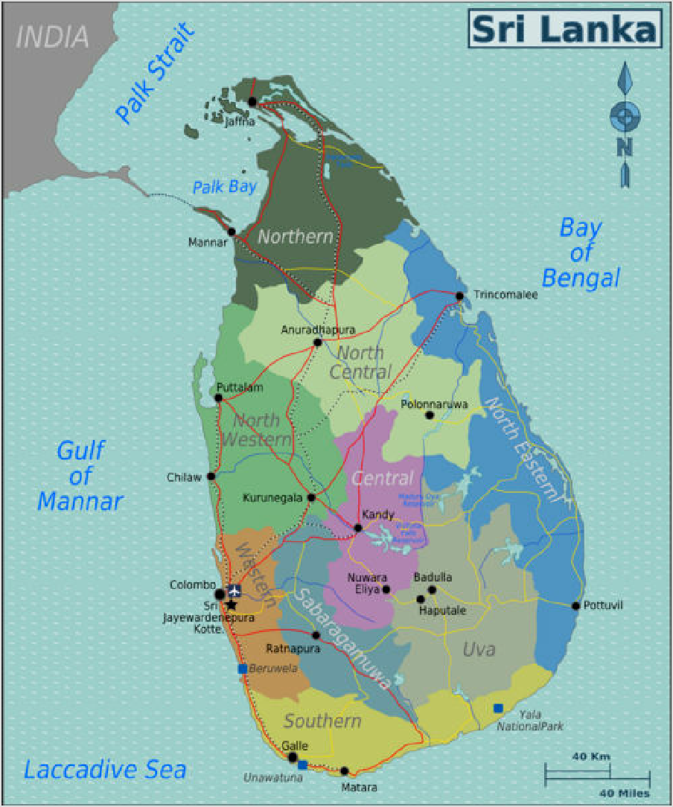Cities
Map of Sri Lanka with provincial regions colour-coded — switch to

- Colombo (Sinhala:
ෙකාළඹ; Tamil:
ெகாழும் பு) — commercial capital and the largest city of Sri Lanka. Hotels, cafés, restaurants, night clubs and shopping.
- Sri Jayawardenapura Kotte (Sinhala: ශ්‍රී ජයවර්ධනපුර
ෙකා්ට්ෙට්; Tamil: ஶ்ரீ
ெஜயவரத்தனபுர

ேகாடைட) — also known as Kotte, new capital of Sri Lanka
- Anuradhapura (Sinhala: අනුරාධපුරය; Tamil: அனுராதபுரம் )
— ruins of ancient capitals (partially restored). UNESCO World Heritage Site.
- Batticaloa (Sinhala: මඩකලපුව; Tamil: மட்டக்களப்பு) — a city built on a lagoon. Beautiful shallow

interactive map

beaches, paddy fields, historical places.
- Galle (Sinhala: ගාල්ල; Tamil: காலி) — famous Dutch fort. Host city of the Galle Literary Festival. UNESCO World Heritage Site.
- Jaffna (Sinhala: යාපනය; Tamil: யாழ் ப்பாணம் ) — northern capital. On display is the rich heritage of the Tamil-speaking community.
- Kandy (Sinhala: මහනුවර; Tamil: கண் டி) — spiritual heart of the country, home to a tooth of the Buddha. UNESCO World Heritage Site.
- Negombo (Sinhala: මීගමුව; Tamil: நீ ரெகாழும் பு) — beautiful landscape and great blue oceans.
- Nuwara Eliya (Sinhala: නුවර එළිය; Tamil: நுவேரலியா) — cool weather, Victorian architecture, top hats, tails and fascinators on race days.

Other destinations

- Arugam Bay (Sinhala: ආරුගම් ෙබාක්ක; Tamil: அறுகம் குடா) – southeast-coast beach town with several top surfing spots
- Sigiriya – famous for its high red stone fortress and palace ruin, the ancient city of Sigiriya. Nearby, Dambulla with its famous cave temple (both UNESCO World Heritage Sites), and Habarana in close proximity of Minneriya National Park

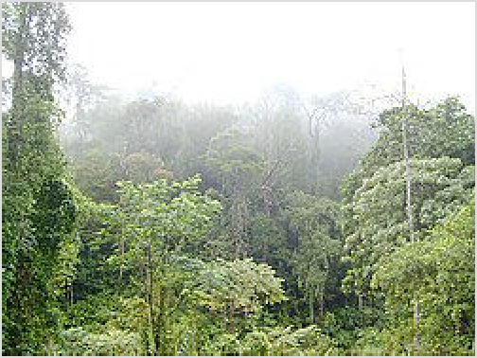3 Horton Plains (Sinhala: ෙහා්ර්ටන් තැන්න ජාතික වෙනා්ද ානය; Tamil: ஓட்டன் சமெவளி) – A cloud forest in the central highlands with many endangered fauna and flora and endless hikes

Morning mist in Sinharaja rainforest
- Kitulgala (Sinhala: කිතුල්ගල; Tamil: கித்துள்கைல) – known for pristine nature and white-water rafting - 4 hours from Colombo
- Mirissa (Sinhala: මිරිස්ස) – beach village and party hotspot on the south coast close to Matara with two good surfing spots
- Pasikudah (Sinhala: පාසිකුඩා; Tamil: பாசிக்குடா) – famous beach resort on Sri Lanka's east coast with white sand beaches and upscale hotels

- Sinharaja Forest Reserve (Sinhala: සිංහරාජ වනාන්තරය; Tamil: சிங் கராஜா வனம் ) – Largest rainforest in Sri Lanka, also a UNESCO World Heritage Site. Extremely diverse fauna and flora. It is home to almost all the endemic species of birds in Sri Lanka. Open at 06:00 onwards.
- Unawatuna (Sinhala: උණවටුන) – beach resort on the south coast very close to Galle
- Yala National Park (Sinhala: යාල ජාතික වෙනා්ද ානය; Tamil: யால ேதசிய வனம் ) – Wildlife safari in Hambantota. Yala national park is a very large animal sanctuary. There are a wide range

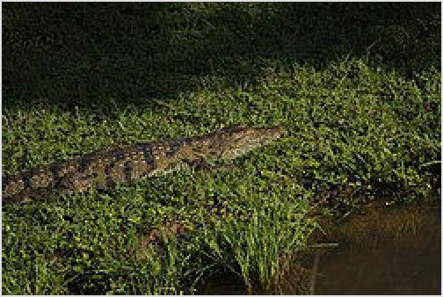crocodile enjoying the sun in Kumana National Park.

of animals that roam around the park, including the rare Sri Lankan Leopard. If you are lucky enough, you would be able to spot them near a watering hole.

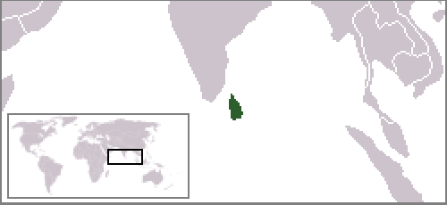Understand
edit on Wikidata

Capital Sri Jayawardenepura Kotte
Currency Sri Lankan rupee (LKR)
Population 21.4 million (2017)
Electricity 230 volt / 50 hertz (AC
power plugs and sockets: British and related types, BS 546, BS 1363)
Country code +94
Time zone UTC+05:30,
Asia/Colombo
Emergencies 119 (police), 110
(emergency medical services, fire department)
Driving side left

History
The indigenous inhabitants of the island are the Vedda people. Groups ancestral to the modern Veddas most likely as far back as 40,000 years ago. Today, Vedda people are a tiny minority and their languages and culture are on the verge of extinction due to cultural assimilation.

Sri Lanka has more than 2,500 years of continuous written history, beginning with the historical epic Mahawansha, and was also mentioned in several ancient Indian texts. One of the most famous is the Ramayana, in which the island, which was referred to as Lanka, was the island fortress of the king Ravana, who captured the wife of Rama, an incarnation of the Hindu God Vishnu. Legend has it that Hanuman the monkey flew over to Lanka and destroyed the

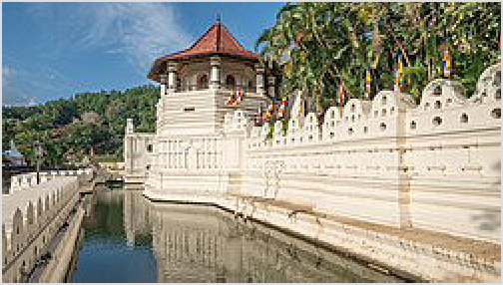capital by setting it on fire, while Rama and his remaining troops later crossed over from the mainland by building a land bridge across the sea.

The Tooth Temple in Kandy

The island's dominant ethnic group, the Sinhalese, arrived in Sri Lanka in the late 6th century BC, probably from Bengal or Maharashtra. Buddhism came to the island from the middle of the 3rd century BC, and a great civilization developed in cities like Anuradhapura (kingdom from c. 200 BCE to c. 1000 CE) and
Polonnaruwa (c. 1070 to 1200). The oldest of Buddhist monuments date to the Anuradhapura period. It was a period where Sri Lanka traded with other civilisations in Asia and Europe, including the Roman Empire. Most notably Sri Lanka exported cinnamon to the rest of the Old World. Other later famous kingdoms are the Dambadeniya, Yapahuwa, Gampola, Kandy and Jaffna Kingdoms.

The second-largest ethnic group in Sri Lanka, the Tamils, began to arrive shortly after the Sinhalese, and their influx was accelerated by the British. Occupied by the Portuguese in the 16th century and the Dutch in the 17th century, the island was ceded to the British in 1796.
With the capture of India, during the rule of king Sri Wikrama Rajasinghe (ශ්‍රී වික්‍රම රාජසිංහ), there were disputes between the king and his subjects, which provided the British an opportunity to invade the Kandyan Kingdom and gain power over the country. The British made a new set of laws and turned Ceylon (as the island was called in those days) into a crown colony in 1815. As Ceylon, it became independent in 1948; its name was changed to Sri Lanka in 1972.
Sri Lanka was engulfed in a bitter civil war for thirty years between the government and the Tamil Tigers, who were fighting for an independent state for the Tamil-speaking minority. The war resulted in the estimated deaths of 100,000 people and destroyed many parts of the country, most seriously the north and east. The war ended in May 2009 with victory for the government, but the consequences persist, and heavy emigration is still slowing the population growth.

After 2009, the economy recovered from the ruins of the civil war under the oligarchic administration of Gotabaya Rajapaksa and his family. However, the government heavily relied on foreign debt to develop the country. The combination of an anti-fertilizer policy that destroyed agricultural production, unbalanced economic structure, corruption and long running economic mismanagement, devastated the economy. In 2022, year-long mass protests resulted in the collapse of the Rajapaksa government, and elections in 2024 swept an opposition centre- left alliance into power. However, the nation's many problems are yet to be solved, and the economic crisis is continuing as of 2025.

Climate
Since Sri Lanka is a tropical country, you can expect the rain anytime of the year in most parts. However, there are two major rainy seasons, each affecting different parts of the island.

The main southwest “Yala” monsoon drenches the west, southwest, and the hill country from April to July. The less severe northeast “Maha” monsoon hits the east coast from November to March. Also worth noting is the generally unsettled weather throughout the country in October-

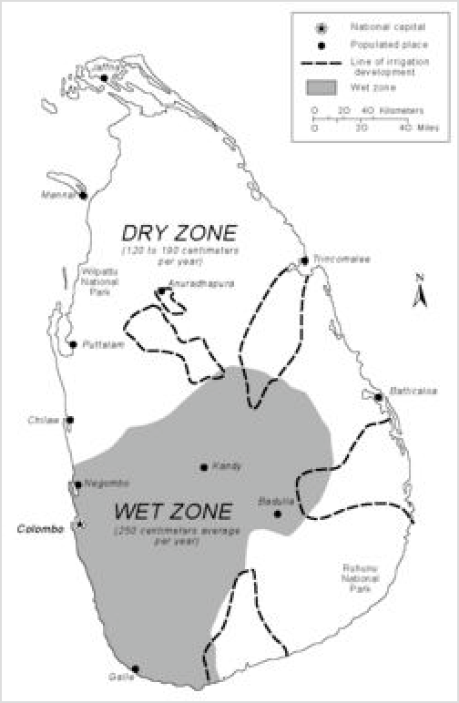November. This is especially the case for the hill country, which is at its sunniest from January-March.

As a result of the two non-overlapping monsoons, there's always good weather somewhere in Sri Lanka. The climate of also changes dramatically from one part of the country to another. For example, at Nuwara Eliya, in the hills of Central Sri Lanka, has a temperature around -5 to 20°C throughout the year, whereas Hambantota, in the dry zone, has a temperature consistently around 30-35°C. The island can roughly be divided into wet and dry zones. The mountains in the south-west capture moisture from the prevailing westerly winds, creating a wet zone. The north is flatter and dryer, and by the time the winds reach the east coast, they have lost most of their moisture.

In general, Sri Lanka also has very hot temperatures all year long, which is why most local men wear sarongs while women dress lightly with a long dress.

Religion
Religion is largely divided along ethnic lines, with the

The mountainous south-west is much rainier than the north and east of the island

Sinhalese majority being almost entirely Buddhist, while the Tamil minority is mostly Hindu, but with significant Christian and Muslim minorities.

Terrain
Mostly low, flat to rolling plain; mountains in south-central interior.

Highest point: Pidurutalagala, 2,524m.
Second highest peak: Kirigalpoththa (Horton Plains) 2,388m. Third highest peak: Thotupola Kanda (Horton Plains) 2,357m.

Visitor information
Sri Lanka Travel (https://www.srilanka.travel/) website

Talk

See also: Sinhala phrasebook and Tamil phrasebook
Sinhala, spoken by the majority Sinhalese, and Tamil, spoken by the minority Tamils, are Sri Lanka's two official languages. English is commonly used in most cities, especially Colombo, Kandy and Galle, and by government and tourism officials – signage is also almost always trilingual. But while most of the people in Colombo can speak English, don't expect everyone, everywhere, to speak it fluently. In tourist areas you will have no problem with English. Most people in rural villages, however, cannot speak any English, beyond a few simple words.

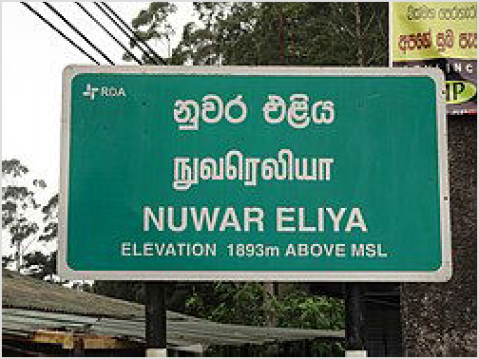Sinhala language The greeting in Sinhala is āyubōvan. It means "May you live longer"; 'Thank you' is sthūthiyi and "how are you" is kohomədə.
Tamil language: The greeting in Tamil is vanakkam; 'Thank you' is nandri.
Sinhala script is curvy while Tamil script is blocky with lots of straight lines. They are easy to distinguish between. Note that Sinhala is the language, while Sinhalese refers to the majority ethnic group.

Given the history of sectarian tensions, language is a sensitive issue in Sri Lanka, and some Tamils may find it offensive to be addressed in Sinhala.

A typical trilingual Sri Lankan sign: Sinhala up top, Tamil in the middle, English at the bottom

Get in
Note: Sri Lankan police will arrest and may deport people sporting tattoos of Buddha or any other tattoos which can be interpreted as having religious significance. If you have such a tattoo then it is strongly advisable to cover it up or avoid visiting Sri Lanka.

Visa rules
Nationals of most countries can apply for an Electronic Travel Authorization (ETA) online, except for nationals of Maldives, Seychelles, Czech Republic and Singapore, who do not need to get an ETA. It allows a stay in the country for 30 days and is valid for six months. Application should be done before entering the country and via the official government website (http://www.eta.g ov.lk/slvisa/). After this, the applicant

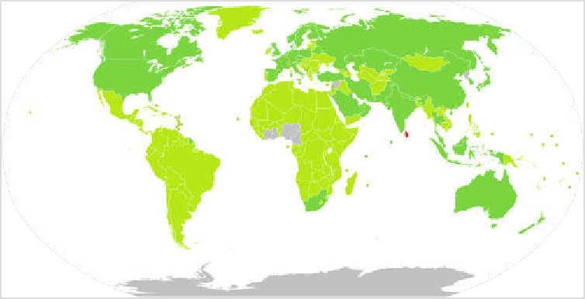A map showing the visa requirements of Sri Lanka, with countries in gold having visa on arrival with an Electronic Travel Authorization

will receive an Electronic Travel Authorization (ETA). Visa charges are US$20 for SAARC countries (South Asian Association for Regional Cooperation: Bangladesh, Bhutan, India, Maldives, Nepal and Pakistan) and US$50 for others (2025), plus $2 processing fee. ETA is supposed to be ready in 2 days, though in practice they can be issued in only 10-20 minutes after the payment is received. Transit visas for up to 48 hours are issued free.

Alternatively, a tourist visa can be obtained without getting a prearranged ETA right at the Bandaranaike International Airport (at a visa desk in the arrival zone before customs) for US$60. Therefore, online visa is not a pre-condition to board a flight/vessel to Sri Lanka.

As of 2025, the required return ticket, as noted in the visa instructions, was not checked for most (if not all) Westerners arriving at the airport. Even if it was and you didn't have one, you should be able to book one ad-hoc using the airport's WiFi.

Important: immigration authorities at Colombo airport are very demanding with respect to the accuracy of the passport number on your electronic travel authorization obtained online. A single digit mistake is taken as a reason to force you to buy a new visa and refer you to some obscure government office in Colombo for refunds of your online payments. Be careful about 1 vs. I and 0 vs. O. The number should exactly match the machine-readable section of your passport, and not anything else (for example, Russian passports have a non-alphanumeric symbol that should be completely excluded).

A lengthy discussion on the Sri Lankan visa situation can be found here (https://docs.google.co m/document/d/14G1n2RcRpu7By4G1EpXirg0WWUMj5K9PysDnAlwNdN0/mobilebasic).

Visa extension
The ease at which you received the original ETA suddenly turns into a bureaucratic nightmare when it comes to visa extension. Be advised, it is probably best to use an agent and save yourself some frustration. If you want to do it yourself, extensions can be made at the Department of Immigration (http://www.immigration.gov.lk), +94 11 532–9000; M-F 09:00-16:30, "Suhurupaya", Sri Subhuthipura Road, Battaramulla. It should also be possible to apply online, but most tourists report that they never received any payment order and had to appear in person. Hence, it's best to sort out the extension right after you arrive while you are still in Colombo.

A visa extension gives you an additional 1–6 months in the country beyond the initial 30-day entry visa. You can apply any time from immediately after entering the country until the expiry of your visa. Extensions beyond this are at the discretion of the department, and incur a Rs15,000 fee plus the extension fee. See above for fees for the first 90-day extension.

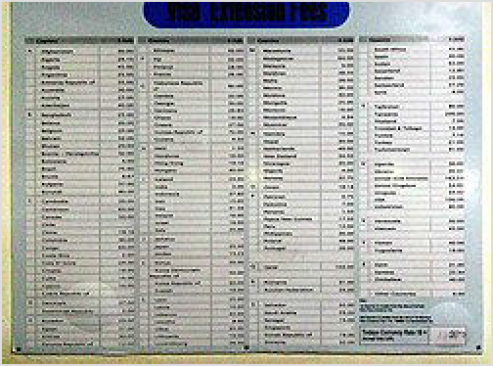The department sets the cost in US dollars, but you pay in Sri Lankan rupees, Rs 10,000 as of 2025. To process the extension, the immigration office requires your passport and an onward ticket. Your proposed stay in Sri Lanka must end at least two months before the expiry date of your passport.

Visa Extension Fees
The immigration office begins processing visa extensions Monday through Friday a bit before 08:30 in the morning. However, a worker usually starts to give out queue numbers and forms some time between 07:00 and 07:30, so arrive early to be among the first processed.

Based on several extensions done in summer 2015, total time is about 2½ hr if you arrive by 07:00: get a ticket around 07:15, submit documents at 08:30, pay at 09:00, get passport back around 09:30. If you arrive at 08:30, the room usually has started to fill and it could be around 3-4 hours. Arriving after 09:30, it'll be full and will take at least 4 hours. Arriving after 11:30 is usually not worth it, because the payment counter closes at 14:30; if they haven't finished the pre-processing necessary to get you to the payment stage before 14:30, you'll have to return the next day.

Agents can do the visa extension for you: they take your passport and documents, wait in line, pay the fees, etc., then return the passport to you. Larger tour groups often use these agents for extensions. The agents know the system: they arrive early and get the first queue numbers.

Because of this, being behind one local agent representing a group of 25 foreigners needing extensions could make your wait time significantly longer. Best advice as an independent traveller is to get your queue number before the local agents: arrive before 07:00, immediately stand waiting at the wooden desk which is on the left just after the entrance, and don't let the agents cut in front of you.

By plane
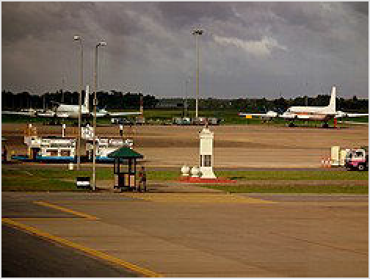As of 2025, Sri Lanka has two active international airports. The main and by far most useful airport is Colombo-Bandaranaike International Airport (h ttp://www.airport.lk/) (CMB ^{IATA}), the journey to Colombo (35 km) will take about an hour by taxi. Jaffna International Airport in the country's far north has two daily flights from Chennai and one daily flight from Tiruchirappalli. This makes sense given that both these destinations are in the Indian state of Tamil Nadu and the north of Sri Lanka has a large Tamil majority. Mattala Rajapaksa International Airport (Hambantota International Airport, HRI ^{IATA}), in the

Colombo Airport
southern part of the country, is rather a white elephant and isn't served with regular international flights.

Sri Lankan Airlines (https://www.srilankan.com/) is the flag carrier, operating flights from cities throughout Europe, Southeast Asia, China, Japan, the Middle East, India, and Pakistan. SriLankan also flies to nearby destinations such as Chennai, Thiruvananthapuram, Mumbai, Delhi, Kochi, Bengaluru and the Maldives. If you have to transit here for 8-48 hours between Sri Lankan Airlines flights, the airline will provide free transit accommodation and meals (as of July 2023 the accommodation is the Full Moon Hotel near the airport) and also a place on a free group van tour of Colombo if requested. This is subject to some conditions, and you need to contact the airline (https://www.srilankan.com/Zh_cn/plan-and-book/transit-acco mmodation) to request it at least 48 hours in advance. Free transit accommodation will not be provided if not booked beforehand.

Emirates Airlines (https://emirates.com), Etihad (https://www.etihad.com), Qatar Airways (https://www.qatarairways.com/), and Oman Air (https://omanair.com/) connect many major European cities and others worldwide to Colombo via UAE, Doha, and Muscat.

FlyDubai (https://www.flydubai.com) connects to Dubai, Air Asia (https://airasia.co m/) to Singapore, Kuala Lumpur, and Bangkok, IndiGo (https://www.goindigo.in/) to many cities in India, and Royal Jordanian (https://www.rj.com) to Amman.

From North America
There are no direct flights that reach Sri Lanka from cities outside Asia, Australia, the Middle East and Europe. From the American West Coast, the distance is almost half the globe. Depending on your preferences and how much spare time you have, you can consider a stopover in Europe, SE Asia/E Asia or Melbourne or take a non-stop flight over the North Pole to New

Delhi or Mumbai from Chicago, Newark, New York City (JFK), or Toronto. In many cases, this may be the fastest route, but check if an Indian transit visa is required. Another fast and easy idea is to use Middle Eastern airlines from the US with stopovers in either Qatar, Bahrain, or the UAE (no transit visa required). For example, the Dubai-based Emirates offers daily flights from SFO, LAX, Houston (IAH), and Toronto (YYZ) with a very short stopover before the short flight to Colombo. Emirates Airlines offer non-stop service to Colombo two to three times daily from Dubai. SriLankan Airlines is part of the Oneworld alliance which allows through ticketing with American Airlines, and several Asian, European, and Middle Eastern airlines.

By boat
As of 2025, Sail Subham operates a regular ferry service between Nagapattinam, Tamil Nadu (India) and Kankesanturai in northern Jaffna, Sri Lanka. As of April 2025, ferries run multiple times a week and depart from Nagapattinam Port (located near the lighthouse) at 07:30, arriving in Kankesanturai by around 11:30. Travelers are advised to arrive at the port by 06:00 to complete immigration, security, and customs procedures. The ferry is in good condition and air- conditioned, offering a comfortable journey.
As of April 2025, a one-way ticket costs ₹4,500, which can be purchased online via credit card or UPI. Arrival into Sri Lanka at Kankesanturai Port with Sri Lanka ETA was smooth and quick, with immigration and customs handled efficiently. Traveling with significant luggage, including bicycles, appeared to be permitted, though additional fees may apply depending on size and weight.

The older Tuticorin (India) – Colombo passenger ferry service remains suspended indefinitely. According to customs officials in Tuticorin, it is illegal for cargo ships to transport passengers from the Tuticorin Port to Sri Lanka.

Get around

Sri Lanka has a strong public transport network linking nearly all tourist destinations, making independent travel very easy. Roads can be terrifying due to local driving traditions — see #Stay safe. Together with occasional massive crowds (especially on holidays), often lacking luggage space, buses may not seem like the most appealing way of travel for some. Yet, they offer great opportunities for interaction with locals, are cheap, plentiful and have different price points (express/local, public/private). Harassment of women travelling alone was frequent in the past, but Sri Lanka seems to have grown up since then.

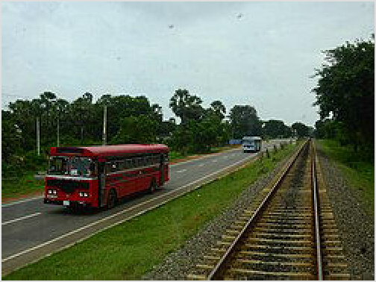A red public bus and a blue private
bus as seen from the back of a train near Jaffna

By bus
Bus travel in Sri Lanka is cheap. For those on a budget, buses are everywhere, although their safety and ease of use are questionable. As a foreigner you may be overcharged — simply ask for a ticket to your destination to get the correct fare, or ask a local beforehand. After a few days you

will get a feel for the correct prices. As a guideline, the price for a normal local bus should be about Rs 5–10/km, the farther the cheaper (5 km ~ Rs 50, and 40 km ~ Rs 200), everything way beyond that is an indication of you getting overcharged. Buses run late, especially in cities, with services ending around 22:00. Google Maps displays incomplete information regarding bus routes and timetables on listings for bus stops. The best bus timetable information on Google Maps appears at bus depots; roadside stops typically have no routes indicated. Check the reviews, as sometimes reviewers attach photographs of the timetables available at the bus stop.

There are three categories of buses in Sri Lanka: Public, Private, and Luxury. Public buses are run by the Sri Lanka Transport Board, and are basic, plain, red-painted buses. Routes and timetables for the public bus network can be searched, with difficulty, here (https://sltb.eseat.lk/ home). Private buses are much more common on the roads. They are still basic, usually painted blue instead of red, but are often highly decorated. These are usually owner-operated and have a reputation for driving dangerously, fast, and packing in as many passengers as possible, in order to make more money. Both public and private buses have the same type of route signage above the windscreen.
If you are planning on splashing out (relatively speaking), luxury buses (aka private A/C buses) run on some (especially tourist) routes for twice the price, which offer online booking, air- conditioning and a guaranteed seat. However, they are still a bit uncomfortable. Luxury bus companies include Superline (https://superline.lk/) and NCG Express (https://ncgexpress.l k/bus-timetables/). Many companies' buses can be booked on the Bus Seat website (https://buss eat.lk). These buses can also be booked on 12GO but at a 10-20% mark-up.
Information on the country's bus network is difficult to find. The nation-wide National Transport Commission website is an atrocious mess. Things are further complicated by the provinces running their own bus networks, so there is no central, up-to-date bus route database. The official price regime enforced by the government can be viewed online (https://www.ntc.gov.lk/ Bus_info/bus_fares.php) (in Sinhala) but private buses sometimes go even cheaper. As well, you can find the most important routes here (https://routemaster.lk/). When paying your bus fare, the conductor can sometimes pocket whatever note you give him and not give you a ticket or any change. All passengers are required to have tickets. Insist on a ticket, and ask what the fare is and try to give exact change.
Bus stations are confusing places, but almost everyone will be delighted to practise their English and help you. Also, when travelling by bus, it is local etiquette to give up the front passenger seats to any monks or priests who board the bus.

Bus travel can be made easier if you arrive early and travel light. If you are carrying a lot of luggage, consider purchasing a seat for your backpack if you don't want to keep it on your lap or under your feet. Tickets are cheap enough for this to be feasible!

By train

Cyclone Ditwah

In November/December 2025, Cyclone Ditwah damaged 70% of the Sri Lankan railway network. Repair work is ongoing (as of February 2026), but several lines are still out of service:

Trains from Badulla and Ella travel as far as Ambewela but don't continue to Kandy or Colombo.
There are no trains from Colombo to Kandy, Matale, Ella or Badulla: These trains only travel as far as Rambukkana
The lines are still open from Colombo to Galle/Beliatta, Chilaw, Trincomalee, Batticaloa and Jaffna.
Further information on Sri Lanka Railways' website (https://railway.gov.lk/web/index.php?opti on=com_content&view=article&id=917&lang=en).

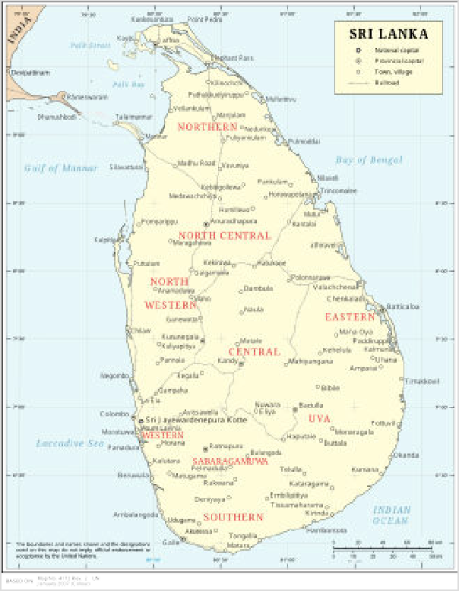Sri Lanka has an extensive railway system serving all major towns and cities in the island except for the North. Trains are reasonably comfortable (1st and 2nd class) and inexpensive if you can buy the tickets directly. You can always buy 3rd class tickets at any station without reservation, also 2nd class is often available.
Sri Lanka Railway map

1st and 2nd class tickets only go on sale 30 days in advance each morning at 10:00 local time and often sell out within minutes to third parties that on-sell them at many times the original price to foreigners. Even if you manage to buy these tickets directly online, you will need to convert your emailed receipt to an actual ticket which can only been done at certain stations (https://seatres ervation.railway.gov.lk/mtktwebslr/ticketprinting locations).

The railway system in Sri Lanka is picturesque when entering the hill country because of the winding tracks along the mountains. Travel by
train is itself a journey to remember, be it travelling to Central Sri Lanka or travelling on the coastal line is just amazing. Preferably choose the express trains, and try to get a reservation beforehand, if you can. There are special Observation cars for tourists to take in the scenery. Trains can be slower than buses, depending if you are on a line that offers an express train or not, but more comfortable and even cheaper than buses.

You can look up train schedules and prices online (https://eservices.railway.gov.lk/schedule/) — only direct connections between stations are shown. Trains in the mountains are often delayed, but there may be additional trains — ask at the station! There is a slightly more user-friendly website (http://slr.malindaprasad.com/) that will give you fares and distances.

There are three classes of railway cars, although 1st and 2nd class are only available on some Intercity and Express trains. Travelling 3rd class is not as bad as it may sound. Often the difference between 3rd and 2nd class is only a missing armrest between seats. Intercity and Express trains have reserved cars which can be booked online in advance on the official website (https://seatreservation.railway.gov.lk/mtktwebslr/).

Trains are sometimes crowded, especially in the morning and late afternoon. Also, observation car seats for the lines popular with tourists (like the Colombo-Kandy line) are often booked out several days in advance in the high season. So whenever possible you should get a reservation beforehand: see Sri Lanka Railways (https://seatreservation.railway.gov.lk/mtktwebslr/) and Train travel in Sri Lanka (https://seat61.com/SriLanka.htm) for more information.

Trains offer good alternatives when they are available, and the standard trains are only slightly more expensive than the private buses, if at all. One of the advantages is that 1st and 2nd class train tickets can be reserved several days in advance. Sri Lankan Railways has a useful website in English. There is no official smartphone app but there is a somewhat useful unofficial one (http s://rdmns.lk/).

The train ride between Kandy and Badulla is especially famous for its spectacular views — particularly between Nuwara Eliya and Ella. If you can, sit on the right side of the train when going in the direction of Badulla, as it offers the better view.

Privately owned train services no longer run. Exporail and Rajadhani Express used to operate air-conditioned and serviced first-class railway cars to certain destinations.

By three-wheeler
One common mode of transport in Sri Lanka is via a three-wheeled automobile appropriately referred to as a three-wheeler (tri-shaw) or tuk-tuk. These operate in a manner similar to taxis, and in many situations are a convenient and cost-efficient way to get around. Road safety is a concern however, as none of them have seat belts and they are open to the sides. They are not permitted at Colombo-Bandaranaike International Airport, so don't let a tuk-tuk driver talk you into hiring him on your departure.

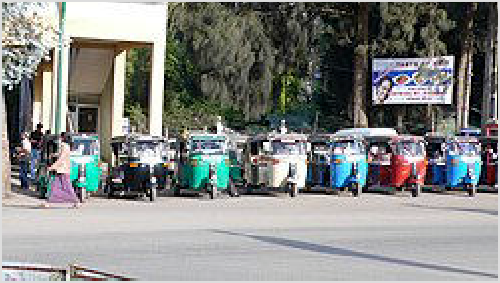Three-wheelers waiting for fares at Nuwara Eliya

Three-wheelers are ubiquitous in Sri Lanka. On any given street, you'll hardly have to wait more than a few minutes without one going by that you can wave down. If you're travelling with luggage, there are slightly larger three-wheelers with more space for your bags that you can look for. While it may be the most novel way to get around, it may not be the most cost-efficient in every situation. Public transport is cheaper by far, and most three-wheel drivers tend to over- charge foreigners. So, never agree to the first price given, or use an app mentioned below. The best price you can get is about Rs 70–100 per km. If you come across a metered tri-shaw make sure the meter is switched on. Taxis are slightly more expensive but much safer. However, you have not experienced everything Sri Lanka has to offer until you travel in a three-wheeler.
Three-wheelers can be hailed via various apps: As of 2025 PickMe and Uber are the most popular. They are also great for estimating prices and bargaining with other drivers. For tourists it's probably best to just rely on these apps, everything else is just a constant hassle regarding the price.

By taxi
Taxis are a better way of getting around Colombo than three wheelers, and they often turn out to be cheaper because they (should) use the meter. Rates are about US$0.55 and they have full day packages (ca. 8 hr and 80 km) for around US$40. They will also take you outstation for around US$0.30-0.35 per km with no waiting charges. You can also set up your own itinerary and travel around that way as opposed to whatever the tour operator tells you.

Alternatively to the meter, there is always Uber and PickMe. Use it to avoid the hassle!

You can also hire a driver with car for a day or for your whole holiday. Some drivers and guides are government-licensed; some are extremely knowledgeable and multilingual, specialising in historical and cultural knowledge, and environmental/natural history for your visits to the ancient sites and the natural reserves.

Of course, if you're not on a budget and especially if you're pressed for time, renting a car with driver for the whole or part of the journey can be a convenient way to follow your itinerary, and will in some cases allow you to see two sites on one day.

By thumb
While not common at all, hitchhiking is very easy in Sri Lanka. The only challenge can be to find a suitable vehicle, because most are tuktuks, motorbikes, tour buses, and regular buses. However, there are enough trucks, regular cars, or vans on the road, so you often don't have to wait longer than 15 min.

While you will easily find buses in most places, for very remote destinations it can be more efficient to just hitch a ride instead of waiting 1 hr for the bus.

Locals usually don't demand money for a ride, unless you happen to catch a tout, but the bus fare (Rs 5-10/km) is a fair compensation if anyone is going to ask. Never pay a tuktuk or taxi fare – demanding such amounts would require a licence.

By rental
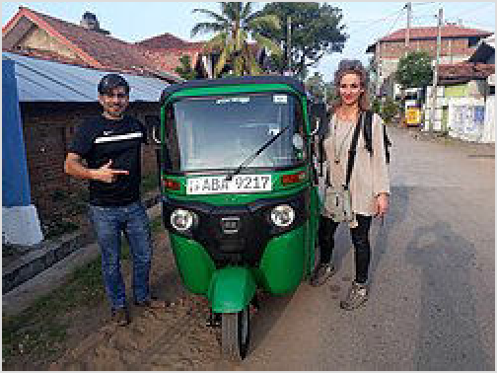You can also rent a tuk-tuk from various companies. Some of these companies offer more services than others. For example, some companies offer help with getting a Sri Lankan licence, free repairs, unlimited kilometers, and tuk-tuk features such as bluetooth speakers, an esky, lockable storage, and 24 hour phone support. Do your research.

A tourist renting a tuk-tuk

While an international driving license is recommended in practise the police will not ask for it. The rule of the administration seems to be not to bother tourists too much and shield them from any corruption-related topics.

Rented cars are less prone to road accidents, which Sri Lanka is badly known for. Daily rates vary between Rs 5,000–10,000 per day excluding fuel, depending on the kind of car you want and whether you book via a hotel or travel agency that will take a commission.

You will need to bring your international driving license and get it validated by the Automobile Association of Sri Lanka to be able to drive on your own. You can opt to pay an agency to do this for you in advance. Otherwise, you must do it in Colombo, and it will take a day. You will find international car hire agencies in Colombo Airport and some local companies in Negombo's beach area.

Traffic is on the left. Some of the main roads are in good condition, but other roads are still narrow and bumpy, especially in the interior. Cyclists, pedestrians and animals are among the cars on the roads, don't expect them to pay any attention to you. Local driving habits are very different from those in the West and traffic is dangerous. Accidents and injuries are common. If you cannot tell whether another driver has seen you, or if you spot a potentially dangerous situation, honk your horn. It is better to honk more than less.

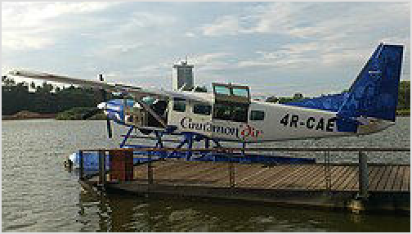By air

An amphibious Cinnamon Air Cessna
As of 2025, there are three domestic airlines connecting destinations around the island with light aircraft or helicopters. They are Senok Air (https://senokair.com/), Helitours (https://www.helitours.lk/), and Cinnamon Air (https://www.cinnamonair.com). Of these, Cinnamon Air is the only airline with scheduled flights. They use both land-based and amphibious Cessnas in their operations, meaning they can land on some of the picturesque lakes and tanks (reservoirs) around the island.

Ratmalana Airport (RML ^{IATA}) is a small domestic airport 15 km from central Colombo. Senok Air and Helitours operate charter helicopter services from this airport.

By tour operator
Tour operators are happy to get you a van and a driver who will take you all over the island but beware, the roads are bumpy and slow. If you book off-the-cuff when you arrive, ask to be shown on a map where you are going before agreeing to any 'tour' of the island and research before you arrive so that you have a clear idea of where you might like to travel. Senseless backtracking to lengthen the trip and increase the cost is a real danger, as is a driver's wish to take you on unwanted shopping expeditions in an effort to gain commission. Travel websites specialising in Sri Lanka are easily found and have greatly increased the choice that is readily available to independent travellers seeking tailor-made tours. The best of them will produce clearly-stated travel itineraries and some are flexible enough to make late changes to itineraries. Ask to see their booking conditions and anti-fraud policies.

See

Admission fees for foreigners to many of the tourist sites are up to ten times those for locals. And nowadays even the remotest Buddha statue or waterfall charges Rs 300 or more.

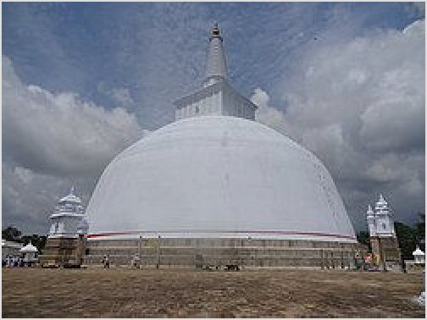Temple of the sacred tooth relic (Dhaladha Maligawa) is a historical structure built around the 16th century to treasure the sacred tooth relic of Lord Buddha. It was built as a palace for the kings of Sri Lanka. which was later turned into a temple. This structure has been reconstructed many time after demolition, including by a terrorist attack during the 1983-2009 civil war.

Some popular sights in Sri Lanka are:

Ruwanwelisaya stupa in Anuradhapura

Lagoons such as Mannar and Jaffna, alongside marshes in these areas.
Beautiful English-style villages in Nuwara Eliya. There are many tea estates and Hakgala gardens too.
The beaches of Unawatuna, Galle, Weligama, Bentota and northern areas are well known, but there are many quieter beaches like Dikwella, Kalpitiya or SK Town.
The unexplored Sri Lanka in Jaffna and the islands in the Northern Province (such as Neduntheevu AKA Delft).
The ancient cities of Anuradhapura and Polonnaruwa (not temples) Chilaw sandpits (great for bird watching)
Pinnawala elephant orphanage
The rainforests of Peak Wilderness Sanctuary, Knuckles Mountain Range and Sinharaja Forest Reserve.
With a recorded history of more than 2,500 years, Sri Lanka has a rich cultural and natural heritage and its World Heritage Sites are among the absolute highlights in the country. With eight recognised entries, Sri Lanka has the second most listed World Heritage Sites in South Asia (only India, with 30, has more). The vast Central Highlands (including three highland parks: Horton Plains National Park, Knuckles Mountain Range and the Peak Wilderness Protected Area) were inscribed in 2010. Other than these, Sri Lanka has identified two prospective World Heritage Sites: Seruwila Mangala Raja Maha Vihara and Seruwila to Sri Pada (Sacred Foot Print Shrine), an ancient pilgrim route along the Mahaweli river.

Itineraries
See also: Sacred sites of the Indian sub-continent
World Heritage Sites Tour in Sri Lanka

Do

Surfing
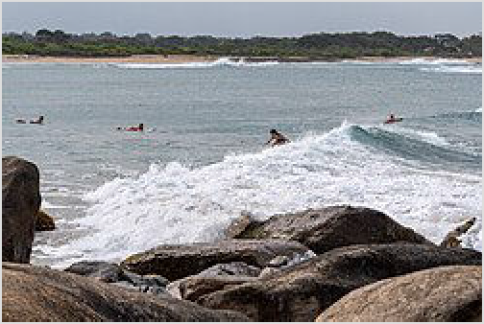From November to April you can surf on the western and southern coast. Best place for the beginners is Weligama on the southern coast. Arugam Bay is famous for surfing.

Kitesurfing
You can kitesurf on the eastern coast. The best place for the beginners is Kalpitiya (Sethawadi and Kappaladi lagoons), where you can find kite schools and the best conditions in Asia.

Surfers at Panama Beach, south of Arugam Bay

White water rafting
White water rafting is done in tropical rain forests, where the rowers, use an inflatable raft which is sent down small waterfalls. Places like kitulgala are famous for this outdoor activity.

Snorkeling
Off the coral a sanctuary near Hikkaduwa is a popular spot to see turtles.

Hiking
Horton Plains National Park offers a nice hiking opportunity to the spectacular view at World's End — quite pricey though.

Likewise Knuckles Mountain Range offers many guided hikes and campsites. Go to nearby Meermure if you are an individual traveller — at least two hikes and some climbing can be found here.

Around Adam's Peak many trails can be found, if you look properly — of course beside the peak itself. In addition, Delhousie (the base camp for Adam's Peak) connects to Gartmore Falls, which also have many trails, waterfalls and river pools in their proximity.

Another great destination is Dolukanda Mountain for an exciting day-hike with IG-finish.

Besides that, around Ella there is Ella Rock (Rs 1,000, but there are many free alternatives) and the popular railway tracks hiking.

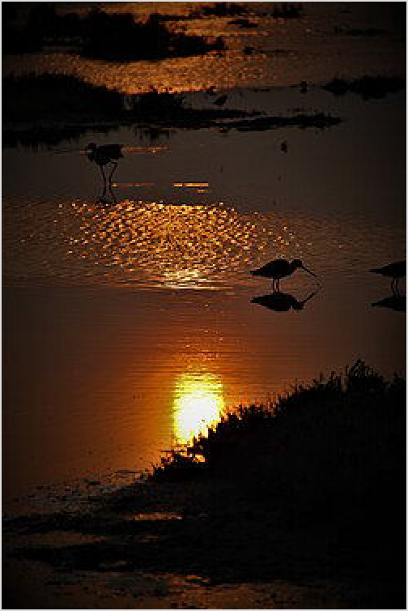Bird watching
Sunset in Mannar
There are over 400 bird species in Sri Lanka, and over 30 of them are endemic. Bird watching is an excellent activity to take on during a visit to the island. The only requirement would be a binocular and a field guide which you can easily purchase from local bookshops and Plazas (When buying field guides, publications of Ceylon bird club (http://www.ceylonbirdclub.com) and FOGSL (https://fogsl.cmb.ac.lk/) (Field ornithology group Sri Lanka) are highly recommended.)

The best place for birdwatching is Kumana National Park, which is known for its multitude of vagrants and migrants. Places like Mannar and Chilaw are filled with migratory birds (mostly waders) during migrating seasons. If you want to see birds from deep forests, the best place for that is the Sinharaja Forest Reserve, the home to almost all the endemic birds of Sri Lanka. Another good place is Bundala National Park near Yala National Park.

Whale watching
This can be done from Mirissa with many companies providing whale watching tours from the harbour. Expect the seas to be heaving, the boat to be lurching, the whales to be few and far between with dozens of whale-watching boats chasing them down and stressing them out.

Sightseeing
Sri Lanka has a history of over 2500 years and many ancient ruins can be seen around the country. If you like archaeology, sightseeing might be a great choice. The suggested places are in the Central Province, places such as Anuradhapura and Polonnaruwa are the most famous for sightseeing.

History and culture
Anytime is good for a cultural trip, but August is ideal for the famous Esala Perehera pageant. Explore ancient relics and World Heritage sites that still captivate despite the years. For cultural insights, check out Love Sri Lanka (https://www.lovesrilanka.org/key-experiences/history-and-c ulture/).

Buy

Money
Exchange rates for Sri Lankan rupee

The currency is the Sri Lankan rupee, denoted by the symbol "රු" or "Rs" (ISO code: LKR). There are coins in denominations of 1 (old version is big and silver, new version is a much smaller with a little change in design),
As of January 2026:

US$1 ≈ Rs 310
€1 ≈ Rs 360 UK£1 ≈ Rs 420
Indian ₹100 ≈ Rs 340
Exchange rates fluctuate. Current rates for these and other currencies are available from XE.com (https://www.xe.c om/currency/lkr-sri-lankan-rupe e)
2 (silver), 5 (gold and silver), 10, (silver) and 20 rupees (seven-sided and silver). Banknotes of Sri Lanka are issued in denominations of 20, 50, 100, 500, 1,000, 2,000 and 5,000 rupees. Coins that are more than a few years old are typically in quite bad condition. Banknotes that are ripped, defaced or written on are not accepted in stores, nor are wet or balled up bank notes. Be alert when accepting change you will come to know that our money is in good condition as the slightest tear or ink stain might mean that they are worthless.

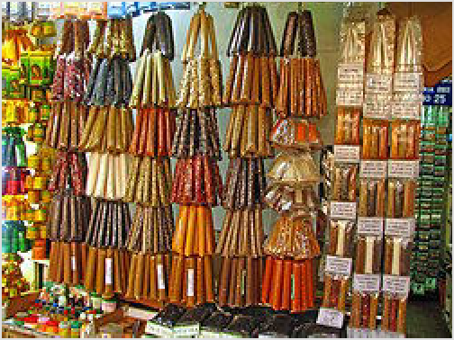Sri Lankan bank notes have telltale anti-forgery markings that travellers should familiarise themselves with. These include a watermark on the left hand side, raised threads of the left and right edges of the note, and a shiny hologram strip down the middle of the note.

Spice shop at Kandy Market

ATMs
ATMs are common in the cities and suburbs, especially at bank branches, less so in the countryside. You can withdraw using debit cards too (Cirrus, Maestro, Visa Electron, etc.) where the logos are displayed. Not every ATM accepts international cards, but many do. Most
ATMs will dispense up to Rs 100,000 at once. Only Peoples Bank and Bank of Ceylon (BOC) seem to charge no fee for withdrawals.

Credit cards and banking services
Be careful of using credit cards, as fraud is on the rise in Sri Lanka. You can't send money by Western Union or Money Gram from Sri Lanka abroad. One can only receive money via international money transfer while in Sri Lanka.

Costs
Accommodation in Sri Lanka is a little more expensive than Southeast Asia. However, food is comparable: local street food costs around €1, a meal in a local restaurant, €2-5, and a bottle of the local Lion beer is €1. All across the country there are simple accommodations, hostels and homestays. As is common in developing countries, the cheapest homestays have no online presence and so cannot be booked online. Prices for such places are generally around €25 per night. On the coast many small boutique hotels have opened up with prices of €30-60 per night.

Shopping
Colombo is the shopping capital, with many malls and plazas selling items of both modern and cultural origins. Rural areas tend to sell handicrafts: reed, cane, cotton, paper, leather, wood, clay, metal, and gemstones are transformed into batiks, toys, curios, jewellery and other hand-made treasures. When out in the more rural areas, you will encounter shops selling low-quality but cheap toys, hats, sunglasses. Counterfeit sunglasses may look good but may not protect your eyes from UV light like the real thing. Many packaged goods are stamped with the Maximum Retail Price (MRP) including taxes. Retailers are not supposed to charge more than this. Although most vendors stick to this rule, you may be charged more than the MRP at tourist destinations or remote places.

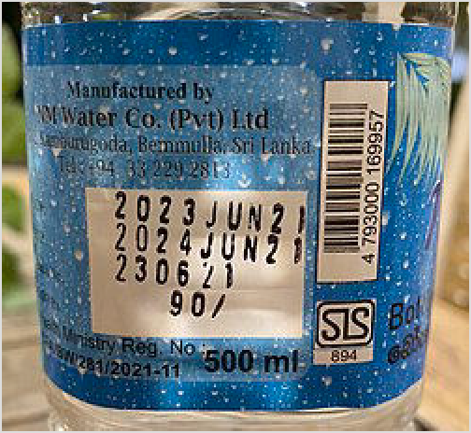This bottle of water has a printed MRP of Rs 90

Gems (mainly sapphires and moonstones) are mined in the country. Both unset stones and finished jewellery are easily found and often well priced. See Colombo#Buy.

Eat

See also: South Asian cuisine
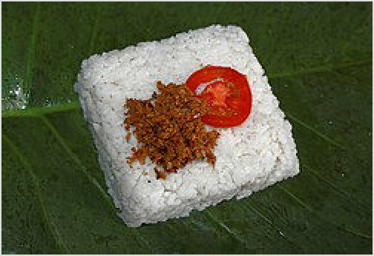Sri Lanka and South Indian food share a lot in common, and many local restaurants describe their menus as Sri Lankan & South Indian. There are several uniquely Sri Lankan dishes, though, such as the different types of hopper, devilled meat and/or fish, cuttlefish, etc., and the common fiery addition to any curry, pol sambol made of grated coconut, red chilli powder and lime juice.

Kiribath, rice cooked in coconut milk

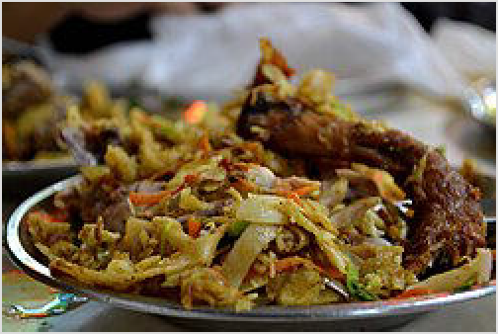The variety of Sri Lankan food is not very wide. Most places sell the same stuff, fried snacks, the same baked goods, kottu, roti, curry, and from time to time you will find a dosa place. Otherwise, there are Chinese and Western restaurants.

Kottu Roti with chicken

Sri Lankan food is generally spicy; you can always ask for less spicy options if you prefer, but it will still be spicy. Sri Lankans eat with their right hands; every eatery can provide cutlery if you can't eat otherwise. But try the Sri Lankan way (tips of fingers only); it's harder than it looks but strangely liberating.
Food is generally very cheap, with a cheap meal costing
about US$1. The most expensive tourist-orientated places seldom charge more than US$10. The staple food of Sri Lankans is rice and curry (Rs 300–500), which is a massive mound of rice

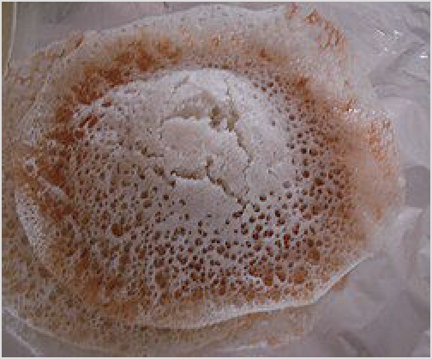surrounded by various curries and delicacies. If you want to eat a cheap lunch you can follow the locals and try crowds at any of the numerous small restaurants, confusingly called 'Hotels'. These normally sell a rice and curry packet, as well as 'short eats', a collection of spicy rolls and samosas filled with potato, fish or chicken. This is ideal for backpackers and those who want to get past the touristy hotels selling burnt chicken and chips; you're charged by how much you eat, and unless you're absolutely ravenous it probably won't cost over a US dollar.
Hoppers

If you are taking road trips outside Colombo, there are
endless options for places to stop on the road for lunch. Rest houses and hotels along major roads throughout the country have good restaurants that offer both Sri Lankan and Western menus. If you are less adventurous, you can easily get good sandwiches and soups at these restaurants. These places have excellent rice and curry dishes, and you will be served many different types of curries over an extremely generous portion of rice.

Kottu (Kothu) Roti (a medley of chopped roti, vegetables and your choice of meat) is a must- have (approx Rs. 1000 as of 2025). It is uniquely Sri Lankan and tastes best when made fresh by street vendors. However, several kottu roti restaurants have been closed down due to their use of stale and old roti, which made some patrons sick. Use caution, and even better, talk with the locals to determine which are the best kottu roti restaurants.
Other foods that you should try include String Hoppers, Hoppers, Pittu and Kiribath. As of 2025, indicative prices for various edibles are:
Sri Lankan breakfast (hoppers, tea/coffee): Rs. 1200 Western breakfast (avocado toast, coffee): Rs. 2500 Chicken kothu roti: Rs. 1000
Devilled fish and rice: Rs. 1500 Fish & chips: Rs. 2000 and up
Seafood share platter: Rs. 5000 and up Pizza: Rs. 3000 and up
Burger: Rs. 1500 and up
There are many upscale restaurants to choose from in the city of Colombo. There are several fine dining restaurants at the 5-star hotels which offer both local and international cuisine. These establishments are found largely in western Colombo (along Galle Road), though more are around Colombo and other major cities.

Fast-food outlets such as KFC, Pizza Hut, Subway and Burger King can be found in major cities.

Snacks such as 'Wade' (wah-dei) can be bought from local stores along with other Indian-based food items such as pouri and hoppers. Most of these food items are prepared with flour and oil. They mostly act as dinner meals and can be found in most Mannar restaurants. String hoppers are mostly seen in these areas, and are quite fulfilling. Most of these products are made to be

enjoyed with a type of curry such as "pol sambol" or dhal. Seafood is present in some of these restaurants. Crabs, lobsters, fish are all fine choices and can be usually found in inns and hotels rather than streetside restaurants.

Ritzbury and Kandos are the main brands of chocolates, Kandos products are higher quality but pricier. Other Sri Lankan-made snacks include Munchee and Maliban brand biscuits.

Ice cream can usually be found in local supermarkets. Two common Sri Lankan-made brands are elephant house and magic. You can also buy ice creams from carts which drive past beaches. The cheapest ice cream is a popsicle called "Captain Cool" which normally costs 20 Rupees. Ice cream should be of recognised brands as others may not be up to adequate standards. Some districts have ice cream three-wheelers that roam around playing a tune. Purchasing your ice cream from a three-wheeler is the second best option as they provide items that are manufactured by the aforementioned brands. You can also find a substitute for popsicles known as "ice packets", though these are generally considered to be unhygienic since they are manufactured by unofficial companies. This item a frozen beverage that you drink by biting off the corner edge of the polythene sheet that coats the contents and sipping from the hole. The packets are uncomfortable to consume, however, they are cheap (Rs. 20) and refreshing.

Although there are many supermarket chains the best ones are Cargills, Keels and Laugh.

Drink

In Sri Lanka, tap water is not safe to drink. Bottled water is cheap (1 litre for Rs. 150 in January 2025) and available everywhere. The more trustworthy brands have the SLS (Sri Lanka Standard Institute) label on the bottle, so look for it.

Fresh milk spoils easily, due to the climate, and so is often very expensive. Powdered or UHT milk is often substituted.
Thambili, the juice from king coconut, is very refreshing. It's sold at the side of streets throughout the island, the coconut is cut open in front of you and it's cheaper than bottled drinks at about Rs. 30 each. The standard international soft drinks are available everywhere. Also ubiquitous are soft drinks from the local producer, Elephant House, which makes a wide range of products - try the ginger beer and cream soda.

The most common local beer is Lion Lager: big bottles in restaurants and bars go for around Rs. 1000 in 2025. If you like dark beer, try Lion Stout. It has a smooth, dense body, chocolatey finish, and high alcohol content! Other brews include Three Coins, which is brewed by the Mt Lavinia hotel chain, allegedly to a Belgian recipe.

The traditional spirit is Arrack, which costs about Rs 4000 a bottle, and is often drunk with club soda. The quality can vary depending on how much you want to pay. A widely recommended brand is "Old Reserve" which is worth the premium price. Other locally-produced spirits include Ascot Dry Gin, which is fairly good and costs Rs. 5,670 a bottle (2025). Local rum goes for around Rs 4000 a bottle. Imported spirits are very expensive.

Sale and public consumption of alcohol is forbidden on Poya Days, which generally fall on the date of the full moon, but occasionally it falls a day either side. If you really want to drink on these days, plan ahead.

Sleep

Accommodation in Sri Lanka has been transformed. What would be recognised as the modern tourist industry began in the 1960s with traditional beach hotels built on the west coast which were aimed primarily at the package holiday crowd and traditional travel operators. But the past decade has brought a major change, with the growth of villas, boutique hotels, and independent properties offering a huge array of choice.

Learn

Buddhist studies and Pali language. The universities of Peradeniya (http://arts.pdn.ac.lk/p ali/) and Kelaniya (https://hu.kln.ac.lk/depts/pali/) offer a variety of Buddhist studies and Pali language courses in English.
Meditation. You may find monasteries and meditation centres that offer meditation courses (generally free of charge) in the Buddhist Publication Society guide (http://www.bps.lk/olib/mi/ mi015.pdf).
Mahamevnawa Meditation Monastery is a good place to learn about Buddhism.
Dancing Sri Lankan traditional dance has three categories: Udarata, Pahatharata and Sabaragamu. There are dance studios around the country where those interested can learn.

Stay safe

Crime
Violent crime is not usually any more serious a problem for tourists in Sri Lanka than it is anywhere. There has been an increase in violent crimes involving tourists in the 2020s, but it is still very rare. Exercise the same care and attention as you would at home. Locals will greet foreigners with a smile and are generally helpful. It is recommended to avoid going alone after dark. Pickpocketing on public transport is uncommon, but take standard precautions.

Road safety
Unfortunately, Sri Lanka's road fatality rate is among the worst in Asia. On average eight people die each day in road accidents. Most accidents happen when overtaking, driving recklessly, or speeding. Bus drivers are known for their especially aggressive and dangerous driving, due to their time constraints, with blind overtaking being very common.

If you rent a tuktuk or motorbike, drive carefully and always leave enough space. When walking along the street, watch for traffic from both directions. Always look both ways when crossing the street. It is best to face oncoming traffic when walking along the roadway.

War and terrorism
Sri Lanka's lengthy and bloody civil war ended in 2009, when the government forces finally defeated the Tamil Tigers, committing war crimes against civilians in the process. However, there are still land mines in rural areas, and the northern and eastern cities are still being rebuilt. Sri Lanka aims to have cleared all land mines by 2028, but it is a lengthy and labour-intensive process for which international funding is uncertain. It is very unlikely that you will encounter land mines, but if you notice anything suspicious, dial 114 to report it to authorities.

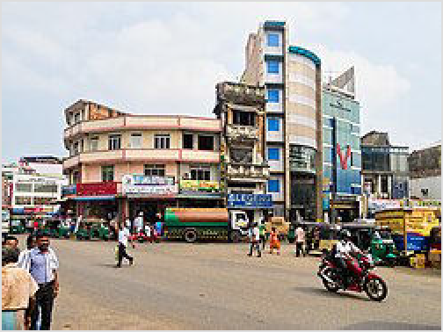Terrorists linked to the Islamic State co-ordinated a series of bombings around the country killing hundreds of people on Easter 2019. However there were no follow- up attacks and the country rapidly returned to normal.

Women's safety and LGBT rights
In general it is comparatively safe to travel as a woman alone in Sri Lanka, but follow some rules for your own safety.

Do not take public transportation late at night.
In rural areas, try to avoid being on the street past nine and if you have to, cover your shoulders and knees.
At the beach try to stay in groups or in tourist areas.

A crumbling colonial-era building is wedged between two newer ones in Pettah, Colombo

Under colonial-era laws which are still in place, homosexual activity between consenting adults is punishable by fines. LGBT travellers should exercise discretion.

Con artists and touts
Con artists and touts are a serious problem throughout all tourist areas, even in 2025. Using the services of a tout for accommodation, travel or shopping will increase the price and open the door to more scams and touting. Tour guides and tuktuk drivers for example can without hesitation be considered touts and must be treated cautiously. First time travellers to Sri Lanka will may find themselves the victim of scams, however seasoned travellers to Sri Lanka are very rarely scammed and it is simple to avoid becoming a victim of scammers by taking precautions:

Do not believe anyone who claims to be in charge of a location (like a bus terminal) without proof.
Be on guard for anybody trying to help you by giving you unsolicited directions or (travel) advice. Don't trust any advice from taxi and tuktuk drivers, especially if they tell you the place you want to go to is closed, dangerous, non-existent, etc. If you are unsure, check a map or ask an uninvolved local. If you have been told your hotel is closed or full, that's mostly BS and not true in times of Booking.com.
Be on guard when a stranger starts a conversation with you. Sri Lankans are shy people, the only reason they pro-actively talk to Westerners is to push some sale, service or donation they make money from. It usually starts with "Where are you from?", "Where are you going?", and "First time Sri Lanka?", which most of the time leads to touting.
If you are a first time visitor to Sri Lanka, do not admit it as it marks you out as someone who does not know the prices of goods and services in the country.

Unless you absolutely have to, do not hire the same driver or guide for more than a day. They are a dime a dozen in each city and the whole country is so small that you will not have trouble getting between towns via bus, train, tuk-tuk or another driver if you have to. Even though you agree on a daily or hourly rate, the drivers will all generally attempt to make more commission out of you by forcing you to visit one of their brother's or friends' businesses (e.g., spice garden, carving or gem shops). Calmly and firmly say you are not interested and if they continue to force you to go then leave them behind and find another driver — they are very common and you will have no problem finding another one.
Never take the service of another "recommended" person or "friend". This will inflate your final price significantly. If you really want to help, rather give that money to one of the poor souls begging along the street.
Never feel guilty about disappointing anyone, this is what touts prey on and they will try to play on your feelings of guilt to get you to pay inflated prices for goods or services.
If you pay for a service or a tour, demand what you negotiated and don't let yourself get sidetracked to other places and things not agreed upon. Stand your ground and threaten not to pay if the situation escalates.
If you get scammed, leave a review with the place that originally caused you ending up with that scam, e.g. your guest house. It is important for other guests to know about this situation,
e.g. overpriced or bad tours, dinners or taxi services, so they don't fall into the same trap. Guest house owners are well aware of their behaviour, it's not helping, it's touting.
Always demand proper and printed tickets when visiting official sights and tourist attractions run by public institutions. No ticket means you don't have to pay! The money paid when no ticket is issued goes straight into the pockets of the ticket seller. This means the government doesn't get this money and cannot maintain the place properly. Don't get fooled by being presented with an empty stack of ripped or used ticket stubs — again, no ticket means you don't have to pay! (Police will be on your side if you want to escalate the situation.) This is especially true for when you use a tour guide. He might claim he does take care of the tickets while actually him and the ticket seller will just split the money between themselves instead of making sure it goes into public funds. This is corruption, do not take part in it and play your role as a responsible traveller!

Stay healthy

Vaccinations are recommended for Hepatitis A+B and Tetanus. Typhus vaccination is also recommended for travellers heading outside of tourist areas especially in the wet season. The CDC also recommends vaccination against Japanese encephalitis (https://wwwnc.cdc. gov/travel/yellowbook/2012/chapter-3-infectious-diseases-related-to-travel/japanese-enceph alitis.htm#1938).
Dengue fever: During the rainy season use mosquito repellent. When head and joint aches occur see a doctor. There are two vaccines available: Dengvaxia and Qdenga.
Chikungunya disease: this mosquito-borne viral infection has been reported by travellers in Galle as recently as October 2025. Its symptoms are painful and long-lasting. Wear DEET- based insect repellent and cover your skin where possible.
Malaria: since 2016 Sri Lanka is declared malaria free zone by WHO (http://www.searo.who.i nt/mediacentre/releases/2016/1631/en/)
Yellow fever: Sri Lanka, like the rest of Asia is free from yellow fever, but a vaccination certificate is required from travellers over 1 year of age coming from infected areas.
Aggressive dogs are a problem in Sri Lanka — stray dogs can be found virtually anywhere in this country. While during the day they are too exhausted to pose a threat, at night they can become a serious issue — best to carry a stick at night for protection if you walk through badly light neigbourhood. Getting a Rabies vaccination could make sense, especially if you stay longer.
Visitors should not drink tap water. Stick to bottled water for drinking and tooth-brushing.

Although snake bites are extremely rare among tourists (comparable to being struck by lightning), anyone bitten should seek prompt medical care. This is true even if the bite doesn't result in any pain and swelling. The National Emergency number is 119. In Colombo, dial either 119 or if you want an emergency ambulance - 110.
There are tiny little flies that live in the sand (inland only, not on the beaches). Any contact with the dry sand usually results in bites and subsequent painful itching.
Outside of Colombo, tampons are hard to find. Bring enough for your trip.
As always, if you can't afford travel insurance, you can't afford to travel. Government hospitals are not free for tourists, regardless of what you may read online. Government hospitals are cheaper than private hospitals, but they take cash only, and do not accept travel insurance like private hospitals do.

Cope

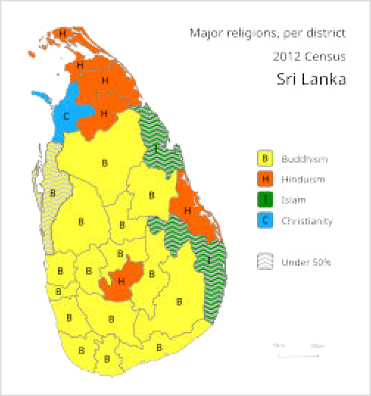Tour guides
Some tour guides may take you to shops where they receive a kickback from the owner for any purchases you make. You can protect yourself from paying these inflated prices by keeping an eye on the prices of items of interest in other shops.

Religion
Sri Lanka has many cultures and religions. Religions contribute to the country's architecture. Temples, kovils, mosques and churches are common points of interest and gathering-places for the community. 70% of Sri Lankans practice Theravada Buddhism as of 2012. Sri Lanka takes its religions seriously; any disrespectful words or actions in public may lead to arrest.

Distribution of major religions in Sri Lanka (2012)

Buddhism — Arrived in Sri Lanka in the 3rd Century AD, now it is the most common religion in Sri Lanka, by far the dominant religion among the Sinhalese, and part of its 2000 years of history.
Hinduism — Sri Lanka's second largest religion can be found scattered across the country, and is the majority religion among ethnic Tamils.
Islam — Arrived at the country via Arab traders; now practised by a significant minority of Tamils, and by the Sri Lankan Malays.
Christianity — Introduced to Sri Lanka by the Portuguese, and practised by a significant minority of Tamils. Most Sri Lankan Christians are Roman Catholics.

Respect

There are several customs that, especially for Western travellers, will take a bit of getting used to.

It is customary to remove shoes and wear respectful attire (i.e., no miniskirts, tank tops, short pants) when visiting temples. It is also the custom to remove shoes before entering a

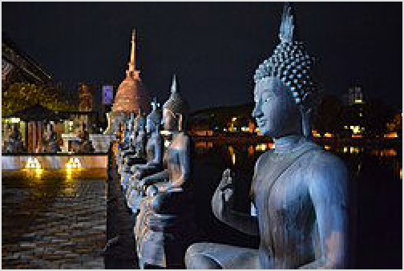home, though this is not as strictly followed as in places such as Japan.
Never touch or pat Buddhist monks, including younger monks and children who practice at a temple.
Do not display tattoos that depict the Buddha. They can be regarded as highly insulting in Sri Lanka, even if acceptable in other Buddhist regions. Arrest and deportation are realistic scenarios, although this last happened in 2014.
Do not turn your back to a Buddha statue while within a reasonable distance. This includes posing for photos, where you should not make arm or body contact with the statue. It is advisable to photograph

Buddha statues at the Gangarama Temple in Colombo

a Buddha statue with all persons facing towards it (as observing it), rather than posing alongside.
Public nudity is illegal in Sri Lanka – nude or topless sunbathing and skinny dipping should be avoided, except in the private beach resorts which allow it.
Although much latitude is given to tourists, it is more polite to use your right hand when handing money and small objects, etc. Of course you can use both hands for something big or heavy.
Be respectful to monks/elderly/disabled. There's no particular etiquette, but do what you'd normally do like giving them a seat on a crowded bus. Likewise, show respect to the poverty- stricken individuals who roam the streets of large cities
It is highly controversial to discuss politics, particularly the Sinhalese/Tamil divide or the LTTE. The 26-year civil war which ended in 2009 saw thousands of attacks throughout the country, including suicide bombings and massacres which have killed scores of politicians and civilians on both sides.
No photography of sensitive locations (inside and outside), and inside of shopping malls and tea factories (outside OK). Be especially careful in Fort, Colombo (except on the beach). If soldiers are guarding something, it probably shouldn't be photographed. Don't rely on signs alone, as sometimes they are old or missing. For example, one end of a bridge may have a "No Photography" sign, but not the other.
Seemingly innocuous public displays of affection between lovers such as kissing and/or hugging may be culturally frowned upon as it is considered to be private behaviour, but it is acceptable in functions and establishments designated for adults such as nightclubs, casinos and beach parties. Much lenience is given to foreigners and holding hands and public affection between parents and their children is not frowned upon.

Connect

Phone
The country code for Sri Lanka is 94. Remove the intercity prefix (0) before the area code when dialling internationally into the country (i.e., 0112 688 688 becomes +94 112 688 688) when dialling from abroad. The two next numbers after 94 represents the area code, they are different for every district for more information see Telephone numbers in Sri Lanka.

Mobile and data
As of 2025, there are the following network providers: Dialog (https://dialog.lk/mobile), Airtel (https://www.airtel.lk/), Mobitel (https://mobitel.lk/) and Hutch (https://hutch.lk/).

4G coverage on the island is good, sometimes slightly depending on the provider. People say Dialog is the best, and indeed Mobitel seems sometimes lacking proper connection.
As of 2025, packages (at the airport) including data go for around €9 including 50-60GB for 30 days, with unlimited social media, calls and messages. Airtel has an offer of Rs 1,188 for 12GB data for 30 days, and unlimited social media and calls. Airtel and Mobitel offer 15GB data for only Rs 1,000. Mobitel has a 1GB/day incl. calls and messages and unlimited social media for Rs 1,390 per 29 days.

Internet
Most restaurants and guest houses have free WiFi.

Retrieved from "https://en.wikivoyage.org/w/index.php?title=Sri_Lanka&oldid=5287981"

